<https://www.gameart2d.com/freebies.html>

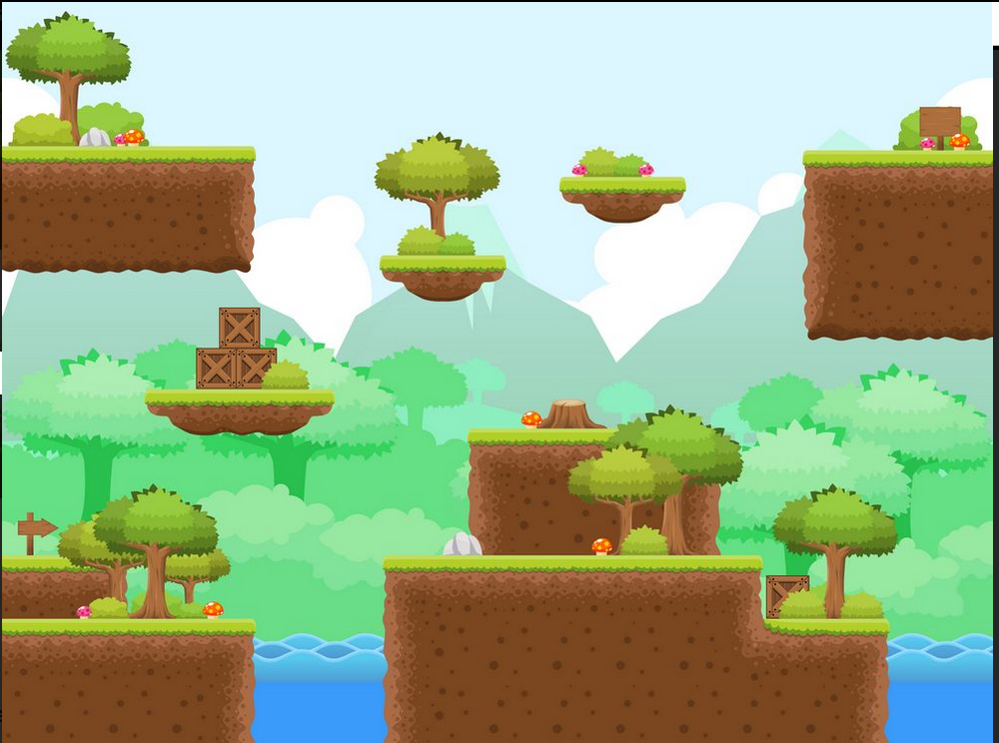

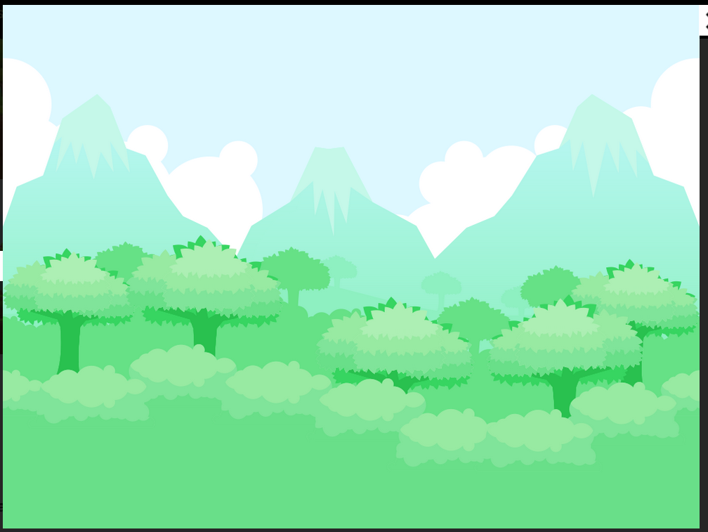

<https://craftpix.net/freebies/>

<https://assetstore.unity.com/packages/2d/environments/free-platform-game-assets-85838>

<https://www.gamedevmarket.net/category/2d/backgrounds/>

<https://frogames.es/recursos-arte-gratuitos-desarrolladores-videojuegos-indie/>

<https://rgoncalves83.itch.io/free-vector-grass-tileset>

<https://www.gameart2d.com/free-platformer-game-tileset.html>

<http://unluckystudio.com/11-free-game-backgrounds/>

<https://craftpix.net/freebies/free-cartoon-parallax-2d-backgrounds/?utm_source=unluckystudio&utm_medium=public&utm_campaign=myself>

<https://www.pinterest.es/wildasp/2d-game-background/>